Project Documentation
1. Introduction
• Project Title: Spendwise
• Team ID :SWTID-2026-2266
• Team Leader: Savitha M
Email id : 24bsccs51@cttewc.edu.in
• Team Members:
– Hemalatha K
Email id : 24bsccs37@cttewc.edu.in
– Mahalakshmi R
Email id : 24bsccs53@cttewc.edu.in
– Natasha Esther J
Email id : 24bsccs27@cttewc.edu.in

2. Project Overview
SpendWise is a secure expense management API designed to help users track and manage their financial transactions efficiently. The system allows users to register, log in, and manage their expenses through a secure authentication process. By using modern backend technologies, the application ensures that user data is stored safely and can only be accessed by authorized users.
The project demonstrates the development of a RESTful API with authentication, database integration, and transaction management. It provides a structured way for users to monitor their spending and maintain financial records digitally.

Purpose

The main purpose of the SpendWise project is to develop a secure backend system that allows users to manage their personal expenses. The system focuses on providing authentication and data security while enabling users to store and access their financial information easily.
It also aims to demonstrate the practical implementation of backend development concepts such as API creation, authentication mechanisms, database operations, and secure data handling. This project helps in understanding how modern web applications manage user data securely.

Features

User Registration
Allows new users to create an account by providing necessary details such as name, email, and password.
User Authentication
Provides secure login functionality using authentication methods such as JSON Web Tokens (JWT).
Expense Management
Users can add, view, update, and delete their expense records.
Secure Data Access
Only authenticated users can access their personal transaction data.
RESTful API Structure
The application follows REST API principles for efficient communication between client and server.
Database Integration
All user details and transaction records are stored in a database for persistent storage.
API Testing Support
The endpoints can be tested using tools like Thunder Client or Postman.

System Architecture
The system follows a REST API architecture consisting of the following components:
Client Layer
API testing tools like Thunder Client or Postman.
Server Layer
Node.js with Express handles HTTP requests.
Authentication Layer
JWT tokens validate user identity.
Database Layer
Stores user details and transaction records.

Setup Instructions
1.Install required software: Node.js, MongoDB, Visual Studio Code, Thunder Client/Postman.
2.Clone or download the SpendWise project and open it in VS Code.
3.Install dependencies using:
npm install

4.Create a .env file and configure:
PORT=5000
MONGO_URI=your_database_connection_string
JWT_SECRET=your_secret_key
5.Start the server using:
npm start
6.Test the API using Thunder Client/Postman (Register, Login, Transactions).
7.If the setup is correct, the server runs on http://localhost:5000 and data is stored in the database.

Folder Structure
SpendWise/
│
├── node_modules/ # Installed project dependencies
│
├── config/ # Configuration files
│ └── db.js # Database connection setup
│
├── controllers/ # Application logic
│ └── authController.js # Handles register and login logic
│
├── middleware/ # Middleware functions
│ └── authMiddleware.js # JWT authentication verification
│
├── models/ # Database schemas
│ └── User.js # User model structure
│
├── routes/ # API route definitions
│ └── authRoutes.js # Routes for authentication APIs
│
├── .env # Environment variables
├── package.json # Project metadata and dependencies
├── package-lock.json # Dependency lock file
├── server.js # Main server entry point
└── README.md # Project documentation

Running the Application
1.Open the SpendWise project folder in Visual Studio Code.
2.Open Terminal → New Terminal in VS Code.
3.Install dependencies using:
npm install
4.Start the server:
npm start(or)
node server.js
5.The server will run at http://localhost:5000
6.Test the API using Thunder Client or Postman (e.g., /api/auth/register, /api/auth/login).

API Documentation
API documentation explains the endpoints used to communicate with the backend server. The SpendWise API allows users to register, log in, and manage expense transactions using HTTP methods like GET, POST, PUT, and DELETE.
The API sends and receives data in JSON format, making it easy to integrate with frontend applications. Important endpoints include user registration, login, retrieving transactions, adding, updating, and deleting expenses.
Proper API documentation helps developers understand the system and ensures smooth communication between the client and server.

Authentication
Authentication verifies a user's identity before allowing access to protected resources. In the SpendWise project, authentication is implemented using JSON Web Token (JWT).
When a user logs in with valid credentials, the server generates a JWT token which must be included in the request header to access protected APIs.
This ensures that only registered users can access the system, keeps user data secure, and prevents unauthorized access.

User Interface
The user interface allows users to interact with the application. In this project, API requests are tested using Thunder Client or Postman, which act as the interface between the user and the backend system.
Users can perform actions such as registering, logging in, adding expenses, viewing transactions, and updating or deleting transactions.

Testing
Testing ensures that the application works correctly and efficiently. In this project, API testing is done using Thunder Client or Postman.
Different API endpoints are tested by sending requests and checking the server responses for functions like user registration, login authentication, and transaction management.
Testing helps identify errors, verify API functionality, and ensure proper communication between the client and server, improving the application's reliability.

11.screenshots or demo
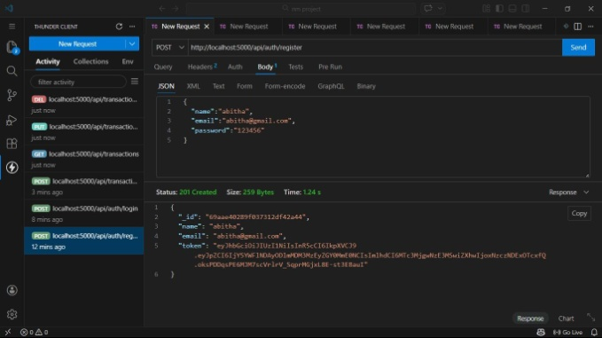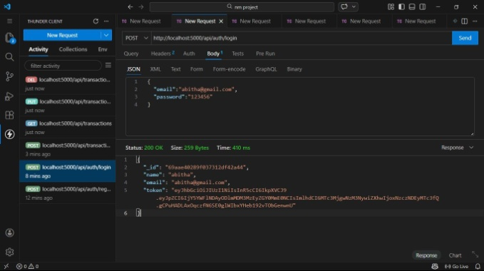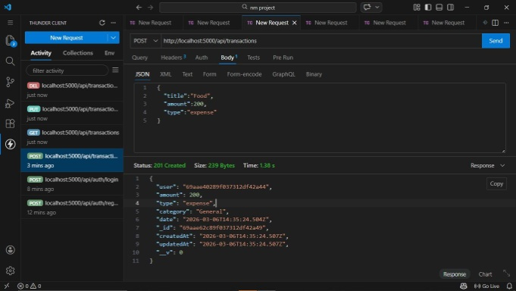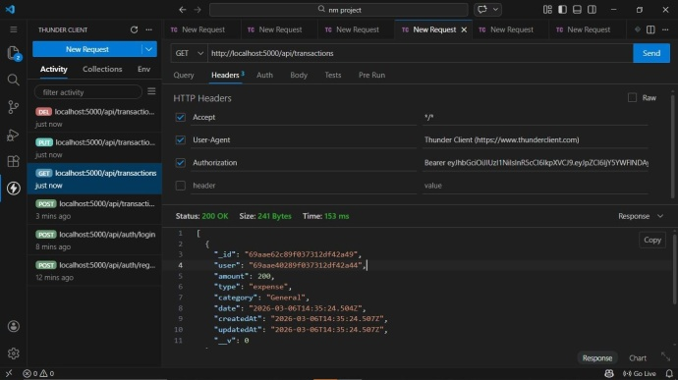
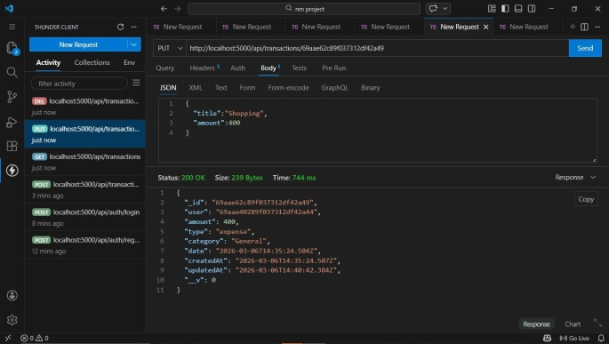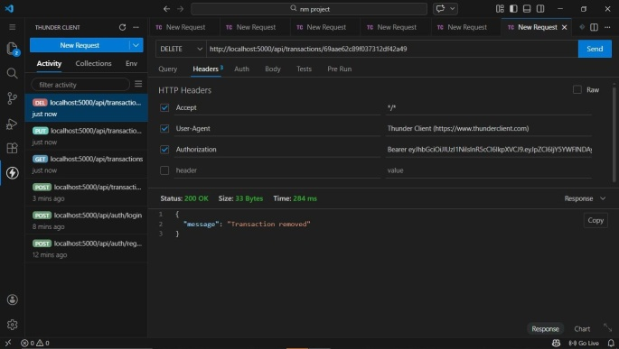

Demo video Link:https://drive.google.com/file/d/1zNfaykEfNoUrrVHOs8D_7zKVdYbRVKcf/view?usp=drivesdk

12.Known Issues
Known issues are the current limitations in the system. In the SpendWise project, the application mainly focuses on backend API functionality, so some features are limited.
Currently, the system does not have a complete graphical user interface and is mainly tested using Thunder Client or Postman. Advanced features like financial reports, charts, and expense categorization are not yet implemented.
The system may also require improvements in security, input validation, and error handling for large-scale use.

13.Future Enhancements
Future enhancements are improvements that can increase the system’s functionality and usability. In the SpendWise project, a user-friendly frontend can be developed using React or Angular for better interaction.
Additional features such as expense categorization, budget tracking, monthly reports, and graphical dashboards can be added to analyze spending patterns.
Security can also be improved with advanced authentication, password encryption, and role-based access control, making the system more efficient and scalable.

